**SEVEN SEGMENT LED USING MAX7219**

**ABOUT SEVEN SEGMENT LED:**

The **seven segments led displays** are the oldest yet one of the efficient types of display used in embedded applications. This display has nothing more than 8 LED inside it. These 8 LEDs are separated into each segments which can be named as a,b,c,d,e,f,g,DP as shown in the picture above. These entire 8 segment LEDs have one end of their pins pulled out of the module as shown above and the other ends are connected together and pulled out as the Common pin. So to make an LED of a particular segment glow we just have to power common pin along with the segment pin.

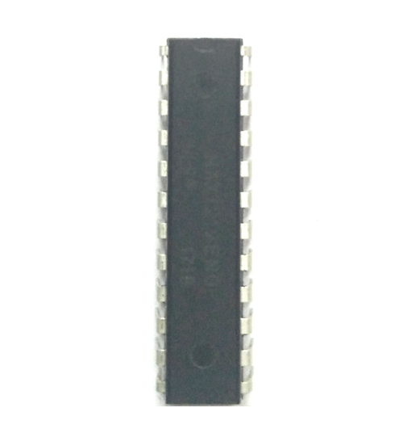

**ABOUT MAX7219 IC:**

The **MAX7219**is an IC designed to control a [**8x8 LED MATRIX**](https://components101.com/displays/8x8-led-matrix-module). The IC is serial input common-cathode (Common Negative) display drivers that interface microprocessors (or microcontroller) to [7-segment](https://components101.com/7-segment-display-pinout-working-datasheet) numeric LED displays of up to 8 digits, [bar-graph displays](https://components101.com/displays/led-bar-graph), or 64 individual LEDs.

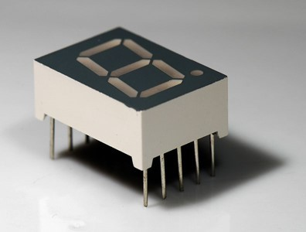

**WORKING:**

We know an LED or Light Emitting Diode, is a solid state optical pn-junction diode which emits light energy in the form of photons. The emission of these photons occurs when the diode junction is forward biased by an external voltage allowing current to flow across its junction, and in Electronics we call this process electroluminescence. The actual colour of the visible light emitted by an LED, ranging from blue to red to orange, is decided by the spectral wavelength of the emitted light which itself is dependent upon the mixture of the various impurities added to the semiconductor materials used to produce it. In this way it works.

**INTERFACING OF THE SENSOR WITH ARDUINO UNO**

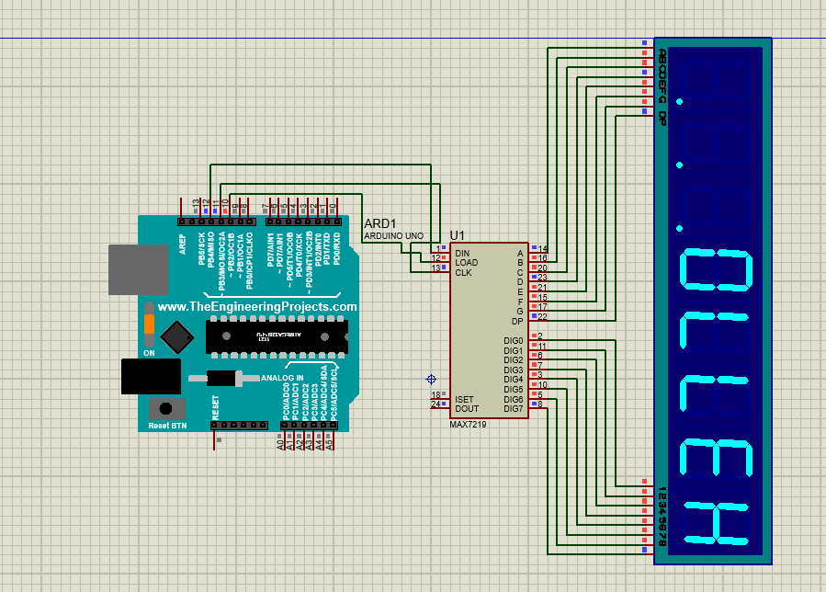

**PINOUTS:**

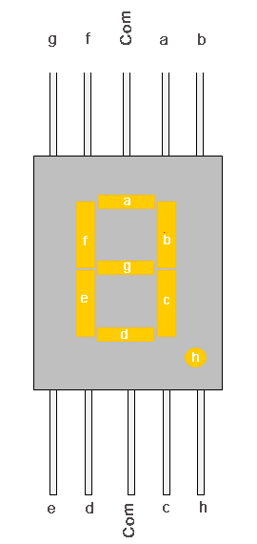

|  |  |  |
| --- | --- | --- |
| **Pin Number** | **Pin Name** | **Description** |
| 1 | e | Controls the left bottom LED of the 7-segment display |
| 2 | d | Controls the bottom most LED of the 7-segment display |
| 3 | Com | Connected to Ground/Vcc based on type of display |
| 4 | c | Controls the right bottom LED of the 7-segment display |
| 5 | DP | Controls the decimal point LED of the 7-segment display |
| 6 | b | Controls the top right LED of the 7-segment display |
| 7 | a | Controls the top most LED of the 7-segment display |
| 8 | Com | Connected to Ground/Vcc based on type of display |
| 9 | f | Controls the top left LED of the 7-segment display |
| 10 | g | Controls the middle LED of the 7-segment display |

|  |  |
| --- | --- |
| **Pin Number** | **Description** |
| **COMMON CATHODE OF DISPLAY SEGMENTS** | |
| 2 | DIG0- Common ground for all eight segments of DIGIT0 |
| 11 | DIG1- Common ground for all eight segments of DIGIT1 |
| 6 | DIG2- Common ground for all eight segments of DIGIT2 |
| 7 | DIG3- Common ground for all eight segments of DIGIT3 |
| 3 | DIG4- Common ground for all eight segments of DIGIT4 |
| 10 | DIG5- Common ground for all eight segments of DIGIT5 |
| 5 | DIG6- Common ground for all eight segments of DIGIT6 |
| 8 | DIG7- Common ground for all eight segments of DIGIT7 |
| **SHARED TERMINALS** | |
| 4 | GND |
| 19 | V+- Power Supply |
| **SHARED SEGMENT TERMINAL OF ALL EIGHT DIGITS** | |
| 14 | SEG A – SEGEMTENT A  of all DIGITS |
| 16 | SEG B – SEGEMTENT B  of all DIGITS |
| 20 | SEG C – SEGEMTENT C  of all DIGITS |
| 23 | SEG D – SEGEMTENT D  of all DIGITS |
| 21 | SEG E – SEGEMTENT E  of all DIGITS |
| 15 | SEG F – SEGEMTENT F  of all DIGITS |
| 17 | SEG G – SEGEMTENT G  of all DIGITS |
| 22 | SEG DP – SEGEMTENT DOT of all DIGITS |
| **FUNCTION PINS** | |
| 1 | DIN -  Serial Data Input Pin |
| 12 | LOAD(CS) – Chip Select or Data shift pin |
| 13 | CLK -  Clock Pin |
| 24 | DOUT -  Pin used to Connect Second chip serially |
| 18 | ISET -  current output adjust pin |

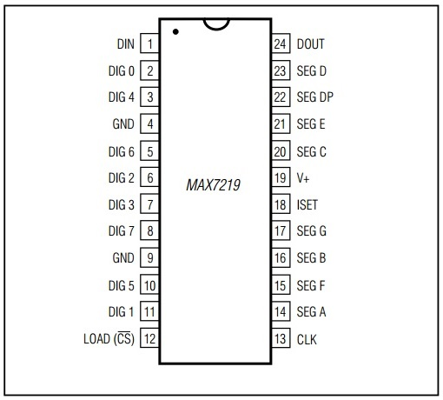

**CODE:**

#include "LedControl.h"

/*

Now we need a LedControl to work with.

***** These pin numbers will probably not work with your hardware *****

pin 12 is connected to the DataIn

pin 11 is connected to the CLK

pin 10 is connected to LOAD

We have only a single MAX72XX.

*/

LedControl lc=LedControl(12,11,10,1);

/* we always wait a bit between updates of the display */

unsigned long delaytime=500;

void setup() {

/* The MAX72XX is in power-saving mode on startup, we have to do a wakeup call */

lc.shutdown(0,false);

/* Set the brightness to a medium values */

lc.setIntensity(0,8);

/* and clear the display */

lc.clearDisplay(0);

}

void hello(){

lc.setChar(0,7,'H',false);

lc.setChar(0,6,'E',false);

lc.setChar(0,5,'L',false);

lc.setChar(0,4,'L',false);

lc.setChar(0,3,'0',false);

lc.setChar(0,2,'.',false);

lc.setChar(0,1,'.',false);

lc.setChar(0,0,'.',false);

delay(delaytime+1000);

lc.clearDisplay(0);

delay(delaytime);

lc.setDigit(0,7,1,false);

delay(delaytime);

lc.setDigit(0,6,2,false);

delay(delaytime);

lc.setDigit(0,5,3,false);

delay(delaytime);

lc.setDigit(0,4,4,false);

delay(delaytime);

lc.setDigit(0,3,5,false);

delay(delaytime);

lc.setDigit(0,2,6,false);

delay(delaytime);

lc.setDigit(0,1,7,false);

delay(delaytime);

lc.setDigit(0,0,8,false);

delay(1500);

lc.clearDisplay(0);

delay(delaytime);

}

void loop() {

hello();

}